**Initial Architecture Design**

**System Architecture Draft**

**Description:** Create high-level system architecture diagrams to visualize the platform’s design. Define data flow, integration points, and key components, such as user interfaces for form upload, dialogue management systems, and AI synthesis modules. This task involves outlining the technical structure and how different parts of the system interact with each other to provide a seamless user experience.

*Our understanding of the system:*

User Interfaces: ReactJS will be utilized to build responsive and interactive web interfaces.

Dialogue Management Systems: This will be managed by a Chatbot Interface that utilizes GPT-4 for understanding and generating human-like responses.

AI Voice Synthesis: GPT-4, coupled with Whisper for voice recognition and synthesis, will enable the AI to handle both text and voice inputs effectively.

Database: Firebase will act as the backend storage solution, offering scalable and secure database services. Another alternative to try could be supabase, to look into for cost & feature analysis.

Cloud Services: Google Cloud Platform is being used by the sponsor for their current hosting and cloud computational requirements.

Voice Agents: Three voice agents will be developed using Whisper to provide a more human, conversational user experience. **<Insert names and differences here>**

Basic high-level system architecture diagram:  
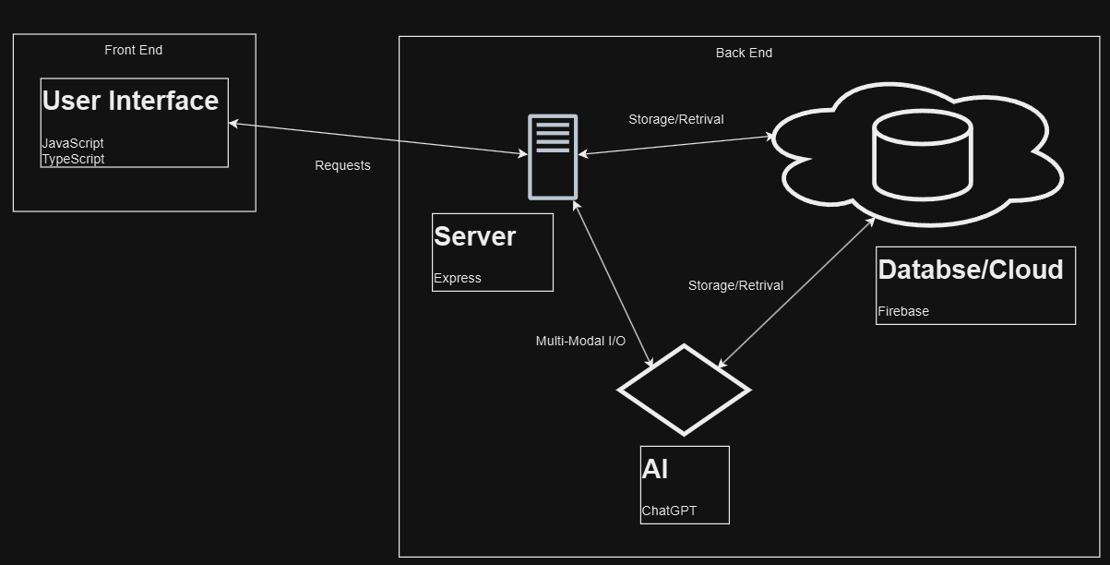

**Technical Requirement Specification**

**Description:** Document the detailed technical requirements for the platform. This includes specifying functional and non-functional requirements, data security, compliance needs, and any other technical constraints. The document should serve as a blueprint for the development team, ensuring that all aspects of the platform are well-defined and understood.

**Data Compliance Requirements:**

GDPR: Ensure data protection for users in Europe, including data minimization and rights to access.

CCPA: Protect privacy and personal information for California residents.

PCI-DSS: Secure credit card transactions to protect financial information. Annual verification for this is required by Stripe and similar services. <Understand what kind of payments are going to be done within the platform>

Security Requirements:

Multi-Factor Authentication (**MFA**): Implement MFA to verify users' identities through a secondary method.

**Regular Security/System Checks**: Schedule regular security audits, penetration testing, and compliance checks to maintain system integrity and data security.

**Non-Functional Requirements:**

**Performance**:

Page Load Time: Aim for a standard of up to 2 seconds, with a tolerance of up to 3 seconds based on server location and cloud service plan. More than that can make users impatient and cause them to exit the platform.

Response Times: Ensure API and system responses are less than 600ms for a smooth user experience.

**Scalability**:

The system should support a scalable number of concurrent users, with infrastructure that can scale dynamically based on user demand and number of active listings. **<Is there a number of users proportional to the number of listings?>**